14.61: a)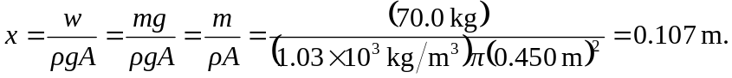
b) Note that in part (c) of Problem 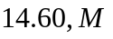is the mass of the buoy, not the mass of the man, and is the cross-section area of the buoy, not the amplitude. The period is then

